* **EDUTAINERS**

**Series – I Specialist of Sciences Date: 01/01/18**

**BIO Ch # 14(1st Half) T1 1st Year Time: 15min Marks: 10**

**Name: _________________________ Objective**

**Q1: Choose the Correct Answer**   
**i. Inner bark has the constituent of:**   
 (a). Xylem (b) phloem (c) cork (d) both a and b

**ii. Which type of cells are directly involved in transport of organic solute:**

(a) sclereids (b) companion cells (c) parenchyma cells (d) sieve tube cells

**iii. 10-25% component of phloem sap is:**

1. Nitrogenous compound (b) sucrose (c) dry matter (d) water

**iv Rate of diffusion of phloem sap is:**

(a) 1m/hr. (b) 8m/hr. (c) 1m/8yr (d) 8m/hr.

**v. Companion cells provide ______ to sieve tube cells:**

(a) ATP. (b) PROTEINS (c) both a and b (d) glucose

**vi. In hydra Through diffusion Ectodermal cells get food from:**

(a) mesoglia (b) mesoderm (c) endoderm (d) environment

**vii. In second growing season the root of beet is:**

(a) source (b) sink (c) both (d) none

**viii. Which of the following phylum has closed circulatory system is:**

(a) Mollusca (b) arthropoda (c) Cephalopod mollusc (d) octopus

**ix. White blood cells are present in which circulatory system:**

(a) open (b) closed (c) both (d) none of these

**x. Anterior end of the body of earthworm is supplied by which blood vessel:**

1. Dorsal. (b) ventral (c) sub neural (d) commissural

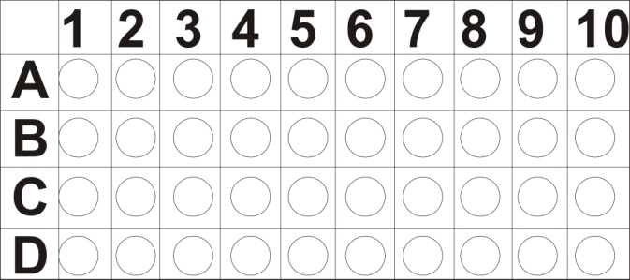

* **EDUTAINERS**

**Series – I Specialist of Sciences Date: 01/01/18**

**BIO Ch # 14(1st Half) T1 1st Year Time: 60min Marks: 30**

**(SUBJECTIVE)**

**Q2: Short Question** **(11 x 2 =22)**

1. Why phloem tissue is said to be a compound tissue? Enlist it constituent cells?
2. Is there any method to know about composition of phloem sap?
3. Why diffusion theory is not appropriate to explain the flow of sap in phloem?
4. Briefly explain mechanism of transport in hydra?
5. Why planaria do not need a specialized transport system?
6. Give main features of circulatory system?
7. Differentiate b/w open and closed circulatory system?
8. Compare the heart of open and closed circulatory system.
9. Draw a flow chart showing circulation in fish
10. Draw a circulatory pathway in vertebrates?
11. Differentiate b/w source and sink?

**Q3: Long Question (8)**

1. Define pressure flow theory and explain it briefly.
2. Compare the open and closed circulatory system?